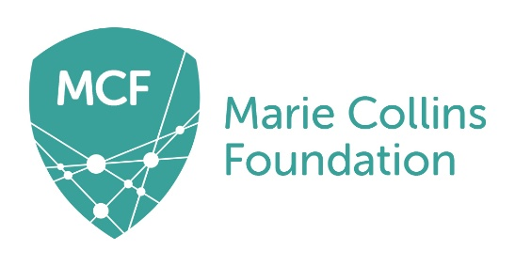

MARIE COLLINS FOUNDATION

Job Title: Media and Communications Officer

Location: Flexible within UK by negotiation. Candidates will be required, at times, to undertake work away from their work-base and to and meet with the staff team on a regular basis.

Reporting to: Victim and Survivor Advocate

Salary: £24,675 - £28,875 pro rata

Working hours: This is a part-time position (0.6 FTE, 22.5 hours a week) with opportunity for flexible working hours by agreement. The pattern of hours may vary according to operational needs and travel requirement where appropriate.

Contract: 12 months fixed term, after probationary period (3 months). The post requires a satisfactory enhanced DBS check.

Annual Leave: 27 days (pro rata) per annum plus statutory holidays.

Job Purpose

To support the development and delivery of MCF’s media and communications activities to build and maintain a consistently high and positive media profile for the work of MCF, driving brand awareness, building loyalty and promoting MCF’s activities to support our mission and strategy. This role will have a strong focus on supporting MCF’s Lived Experience Group in elevating the voices of victims and survivors through creative communications in line with the Advocacy Strategy.

Duties and Responsibilities

Media:
- Support the development and delivery of reactive and proactive external media engagement, handling incoming media requests and briefing journalists where necessary.
- Working with the team to identify relevant opportunities for MCF to react to breaking news and proactively secure media coverage during awareness weeks and resource launches
- Amplify MCF’s public profile by shaing insights to strengthen MCF’s authority in relation to Technology-Assisted Child Sexual Abuse (TACSA).
- Work closely with MCF’s Lived Experience Group in producing communications and engaging in media opportunities to shape policy and campaigns related to MCF’s work.

Social Media:
- Handling day-to-day scheduling, monitoring and interactions across MCF’s social media channels (LinkedIn, Facebook, Instagram, X, YouTube) to grow and maintain audience engagement.
- Create compelling and engaging content for MCF’s social media channels, including sourcing images, creating and editing videos, and designing graphics in line with MCF’s values and brand guidelines, including language and tone of voice.

Digital Communications:
- Keep the MCF website up to date, writing and uploading regular news articles, blog posts and other content to highlight the work and impact of MCF.
- Produce regular newsletters, distribute to relevant audiences and track campaign analytics.
- Design and produce digital marketing assets for advertising, external agencies and other channels as required, to deepen engagement with existing supporters and donors, acquire new supporters, and promote the work of MCF.

Communications Strategy:
- Support the development of a communications strategy and co-ordinate the development of a pro-active and reactive communications plan in line with MCF strategic goals.
- Develop creative communication campaigns to promote MCF as the go-to organisation for information relating to TACSA.
- Build relationships with key stakeholders to amplify MCF’s work and messaging.

General:
- Using analytics and feedback to assess the effectiveness of all external communications.
- In all communication ensure consistent messaging, branding and tone of voice for the intended audience and that content conforms to MCF’s branding guidelines.
- Work collaboratively across teams to align communications with organisational priorities.
- Attend key events to capture content and represent MCF as a spokesperson when needed.
- To carry out, within reason, any other duties necessary to the smooth running of the service.

